TravelMatch AI

Project Prototype Documentation

1. Project Overview
TravelMatch AI is a prototype travel recommendation app that helps users discover destinations based on the type of experience they want, rather than only through generic search results. Instead of simply asking where a place is popular or highly rated, the app asks what kind of traveler the user is and what they care about most. For example, a user may care most about views, history, food, safety, events, activities, or budget. The system then uses those preferences to recommend destinations that are the best overall fit.
The purpose of this project is to create a more personalized and explainable travel planning experience. Many travel tools can already show popular destinations, attractions, hotels, and restaurants. However, they often do not clearly explain why one destination is a better fit for one person than another. This project explores how AI can be used to build a more taste-based recommendation system that feels closer to having a personalized travel advisor rather than using a standard search engine.
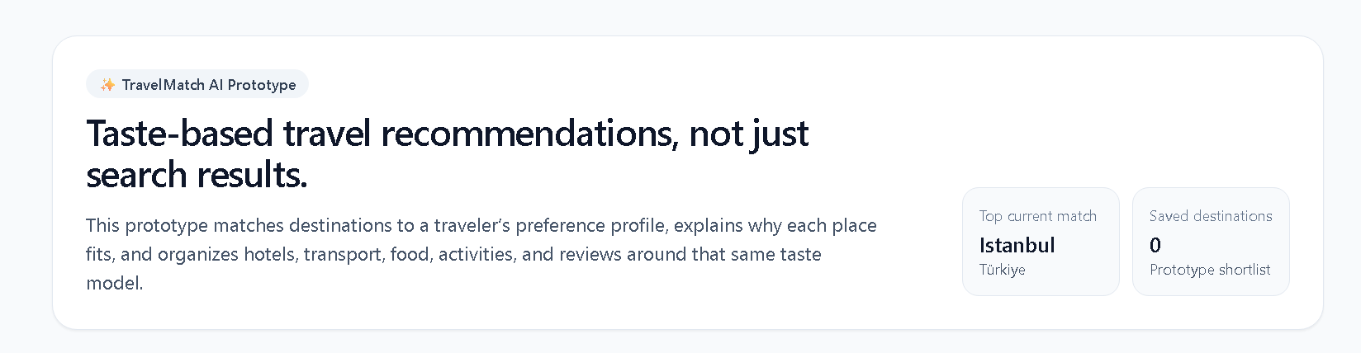

2. What Makes This Different From Google Search
The main difference between this project and a standard search-based travel tool is that TravelMatch AI is designed around personal fit rather than broad popularity. Traditional search tools are useful for finding information, but they still require the user to compare options manually and decide which destination best matches their style. This project tries to reduce that burden by letting the AI interpret the user’s preferences and generate destination matches directly.
Another important difference is that the system is designed to explain its reasoning. Instead of only listing cities, it identifies why a place is a good fit, such as strong historical depth, high food relevance, scenic appeal, or safety. The user is not just shown recommendations; they are also shown the logic behind them.
The project also introduces a review intelligence layer. Rather than treating all reviews equally, the idea is to organize and interpret reviews by traveler type. For example, a solo traveler, a foodie, and a budget traveler may all experience the same destination differently. This creates a more personalized review experience and helps users focus on the reviews that are most relevant to them.
In short, the unique value of the project is that it moves from “what is popular?” to “what is most suitable for this specific traveler, and why?”

3. Core Features of the Prototype
The current prototype includes several core components that represent the main idea of the final app.
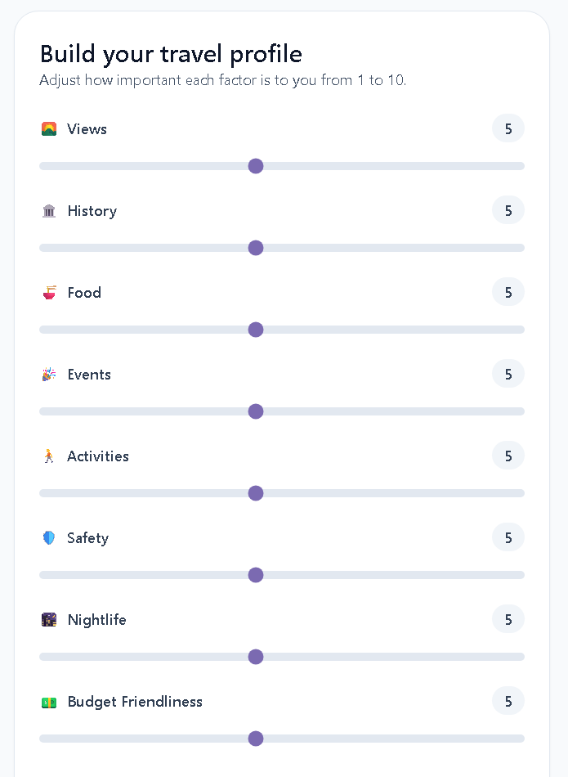
The first component is the travel preference builder. Users can adjust the importance of categories such as views, history, food, events, activities, safety, nightlife, and budget friendliness. These preferences act as the foundation for the recommendation process.

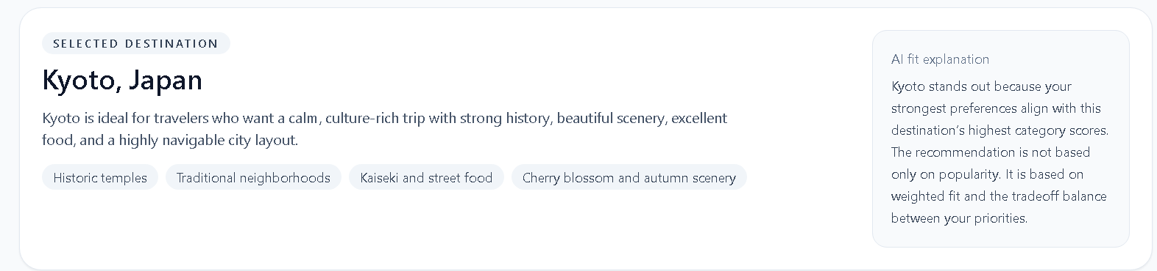
The second component is the AI destination matching system. Based on the preference profile, the app ranks destinations and gives each one a match score. It also highlights the strongest reasons behind the match so that users understand why a destination is being recommended.

The third component is the destination detail layer. After selecting a destination, the app provides related recommendations for transportation, residence, food, events, and activities. This helps extend the recommendation logic beyond the destination itself
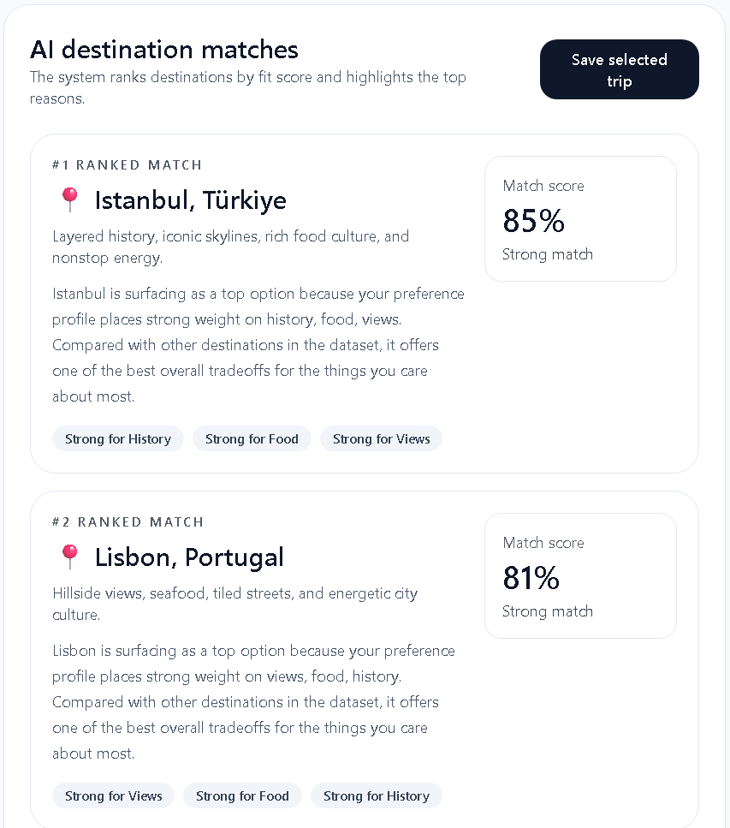

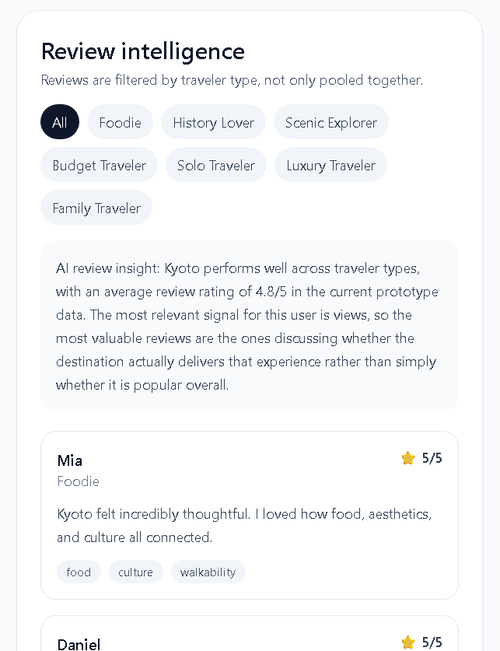
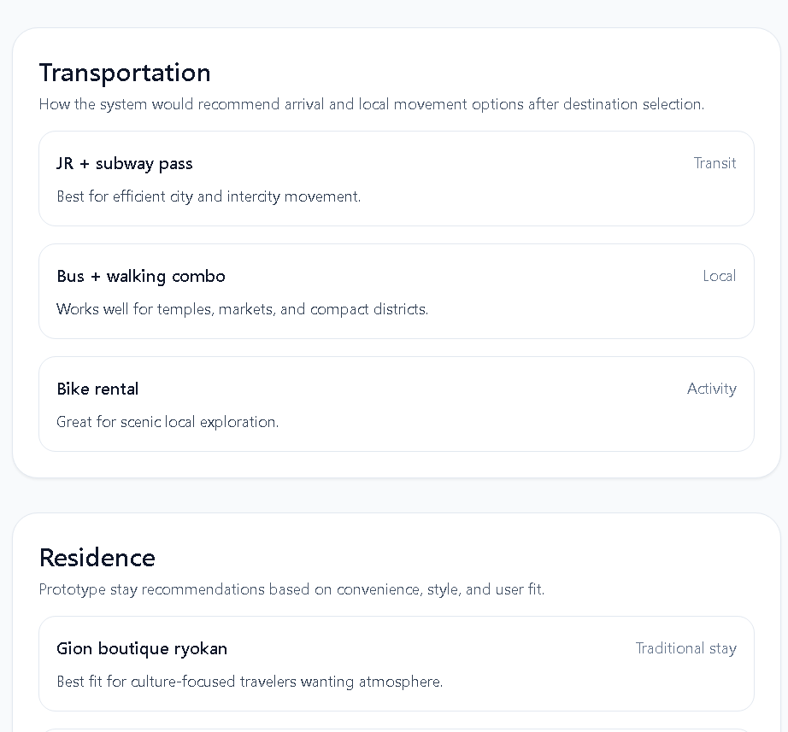
The fourth component is review intelligence. The review system is meant to be more than a generic comments section. In the prototype, reviews are grouped by traveler persona so that users can better understand how different kinds of travelers felt about a destination.

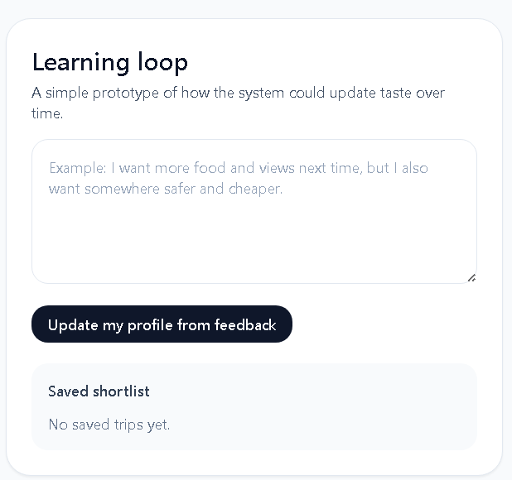
The fifth component is the learning loop. The prototype includes a basic feedback mechanism where users can describe what they want more of next time, such as more food, more scenic value, or a safer or cheaper destination. This suggests how the app could gradually learn user taste over time.

Link to video demo: https://drive.google.com/file/d/1bTi2JypKPTyoMMuhItuwrJ9ae4x3ix_q/view?usp=sharing

4. Early Prototype and Design Evolution
The first version of the idea was much simpler. Initially, I imagined an app where users would type in keywords like “views,” “history,” or “food,” and then receive destination suggestions. However, this felt too close to standard search behavior and did not make the AI aspect strong enough.
As I refined the concept, I shifted from a basic keyword system to a weighted preference model. This was a much stronger direction because it allowed the app to represent differences in user priorities. A traveler who slightly cares about history but strongly cares about food and safety should not get the same result as a traveler who primarily wants museums and historical sites.
I also realized that the project needed a stronger differentiator from standard travel websites, so I added the idea of review intelligence. Instead of simply displaying comments, the app could eventually sort and interpret reviews based on traveler type, helping users see which experiences are most relevant to them.
The overall design evolved from being a general travel search idea into a more specific AI taste-matching system. That shift made the project clearer, more original, and more aligned with the goal of building an AI-supported experience rather than a normal information app.

5. Development Plan
For the prototype, I focused on building a front-end experience that demonstrates the product concept clearly. The app was developed as a website prototype that could be run in the browser. The main goal was not to build a fully connected production app yet, but to create a working proof of concept that shows the user flow and core AI-driven interaction model.
The next stage of development would involve improving the data layer and making the recommendations more realistic. In a fuller version, the app could use live travel data, user-generated reviews, structured destination information, and possibly event, restaurant, hotel, or transportation APIs. That would allow the experience to move from a concept demonstration to a more intelligent and useful travel recommendation platform.
A future version could also include user accounts, saved trips, review submission, and a stronger recommendation engine that updates based on previous trips and user feedback.

6. AI and Coding Tools Used
AI played an important role in the prototyping process. I used AI to help brainstorm how the project could be differentiated from existing travel search tools, especially by shifting the concept toward taste-based matching and review intelligence. AI was also used to help structure the front-end prototype and generate a working website implementation of the interface.
More specifically, AI helped me translate the app idea into a real coded prototype by assisting with layout logic, component structure, and interface behavior. This made it possible to move from a concept into a visual and interactive prototype much faster than if I had started every part from scratch.
At the same time, I used my own judgment to refine the product direction, decide what features mattered most, and shape the concept into something more original. AI was useful as a design and coding assistant, but the project idea, positioning, structure, and feature priorities were guided by my own decisions.

7. Troubleshooting Log
One challenge I ran into was that the original concept felt too similar to a normal travel search website. If the user simply typed in interests and got destination suggestions, it did not feel different enough or AI-driven enough. I addressed this by shifting the project toward a weighted preference model and making the app focus on personal fit rather than generic search.
Another challenge was deciding how to make the review section more meaningful. A normal review section would not add much originality, so I reframed it as a review intelligence system that could eventually group or filter reviews based on traveler type. That made the feature feel much more connected to the AI aspect of the project.
A third challenge was scope. There are many possible travel-related features, such as live maps, booking, real reviews, and external event data. For the prototype stage, I narrowed the focus to the features that best communicate the idea: taste-based matching, explainable recommendations, and aligned destination follow-up suggestions.

8. Source Code and Prototype Access
https://aw5193-source.github.io/projectprototype/
Prototype code is in github’s repository projectprototype index.html

9. Support I Need From the Instructor
At this stage, the main support I would benefit from is feedback on scope and direction. I would especially like feedback on whether the current level of differentiation from standard travel tools is strong enough, and whether the review intelligence idea feels like a meaningful AI feature to keep developing.
I would also appreciate guidance on how ambitious the final version should be in terms of data integration. For example, I would like feedback on whether it is better to stay focused on a polished recommendation prototype or try to connect more live travel data sources before the final submission.
Finally, I would appreciate feedback on the user experience design, especially whether the current structure of preference input, recommendation ranking, and destination detail flow is clear and intuitive.

